**Capstone Check Point – 3**

**AWS**

**Task 3.2 [AWS]**

**1.Datasets moved to AWS s3 bucket.**

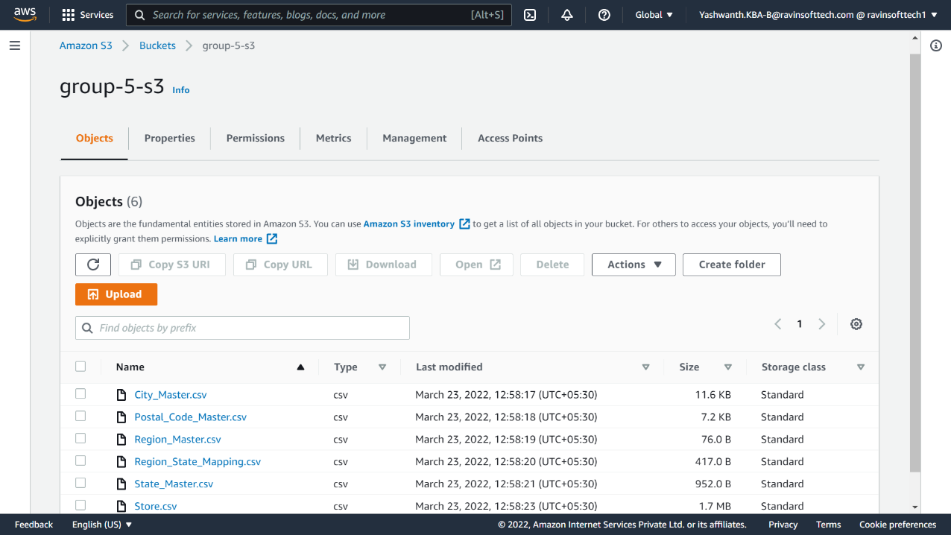

**2.Creating a redshift cluster.**

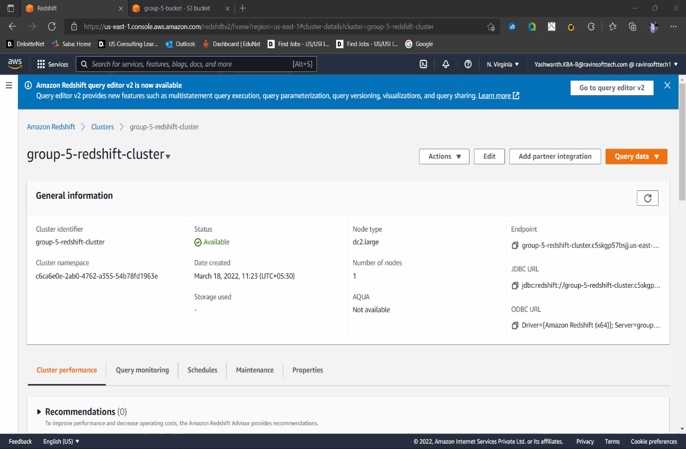

**3. Creating tables in redshift query editor.**

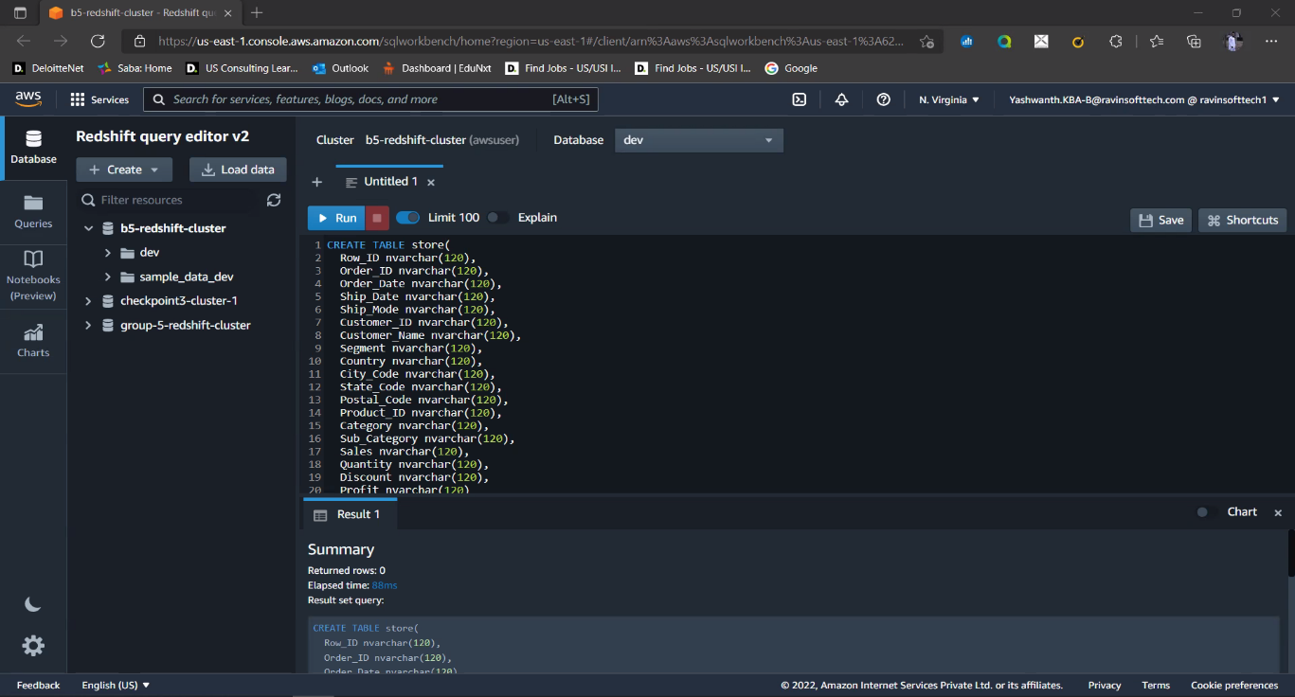

**All the tables created.**

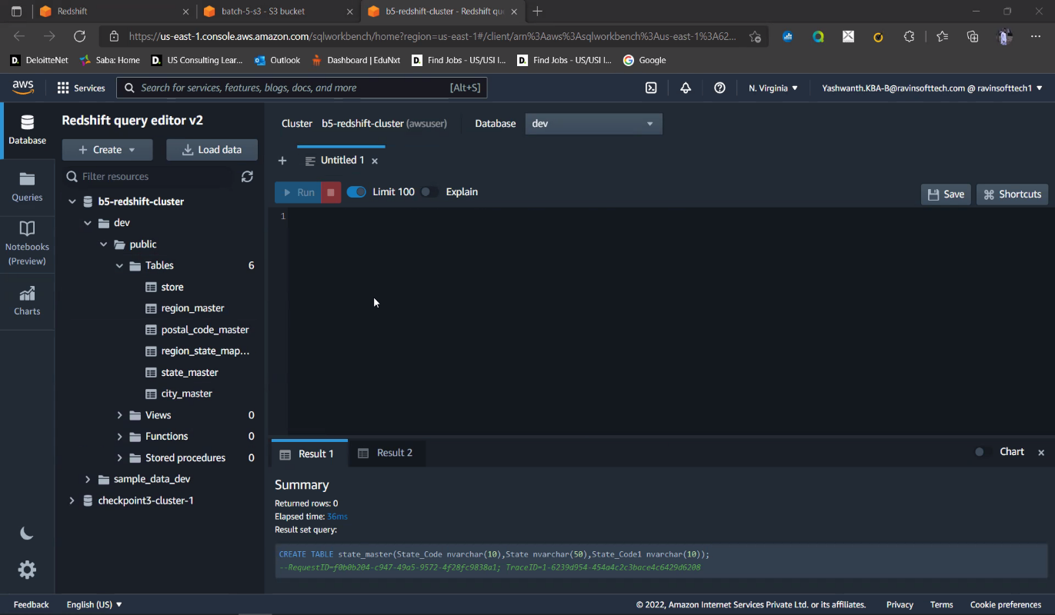

**4. Create a data pipeline/copy command to move the data from storage to data warehouse (Redshift).**

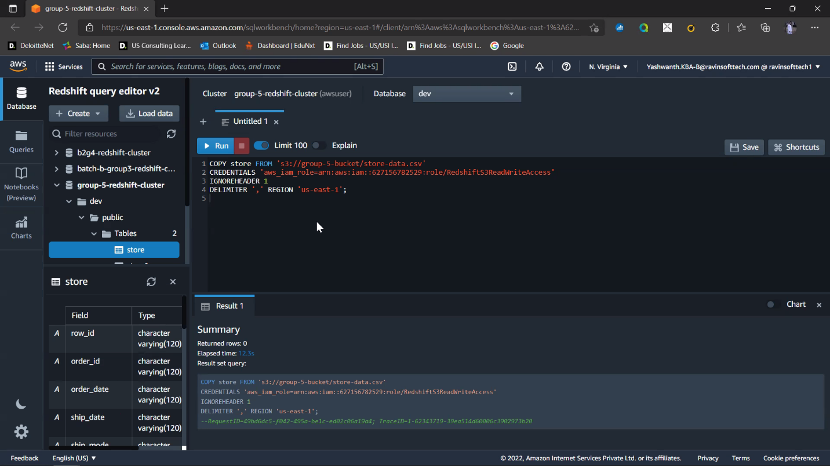

**Displaying the store data post the data transfer from storage(S3) to warehouse (Redshift).**

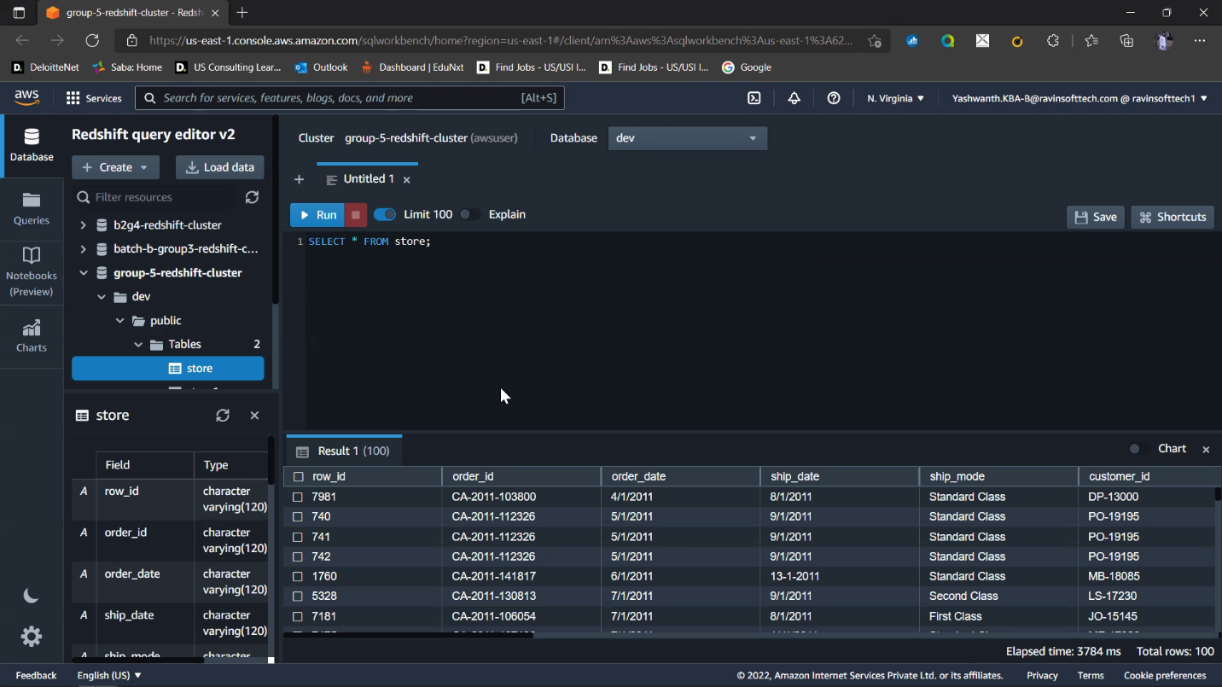

**5. Connecting the Redshift data to PowerBI.**

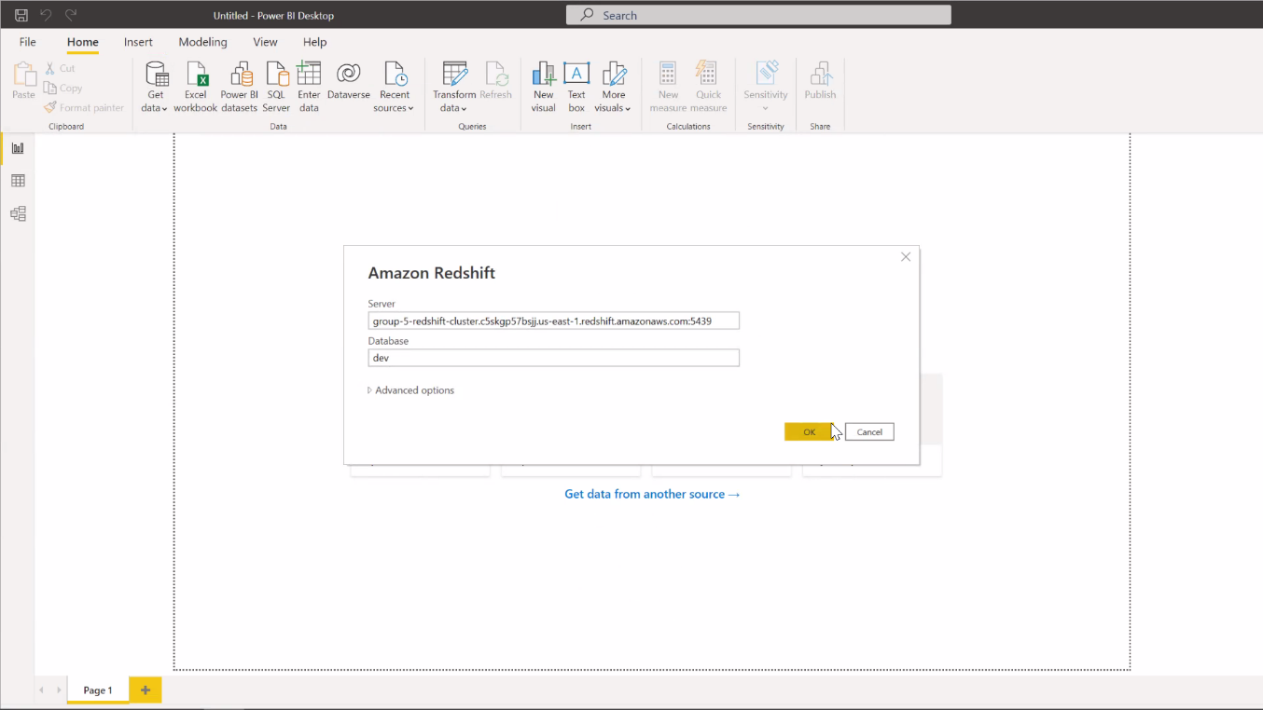

**Connected Successfully!**

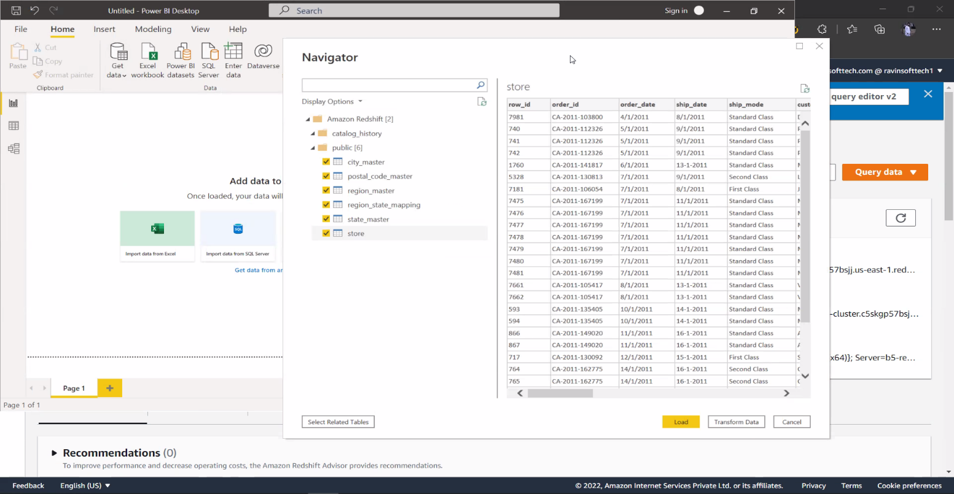

**6. Visualizations using PowerBI.**

**Establishing relationships between tables.**

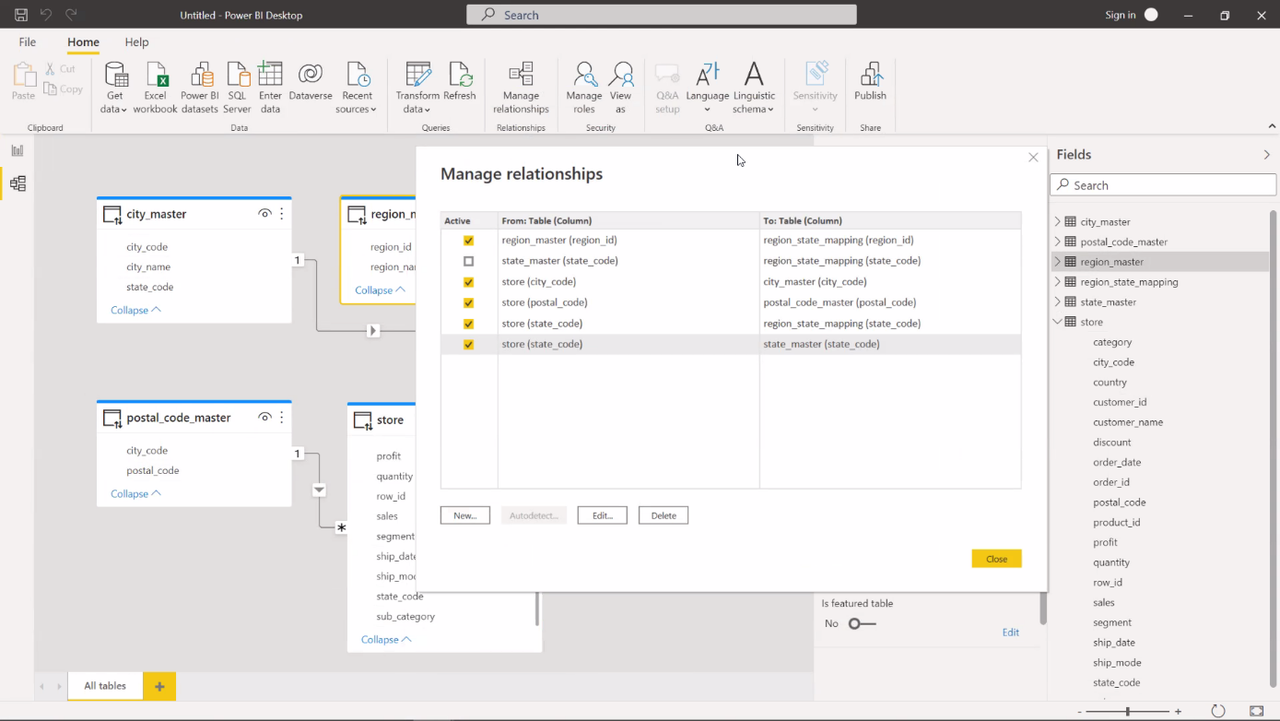

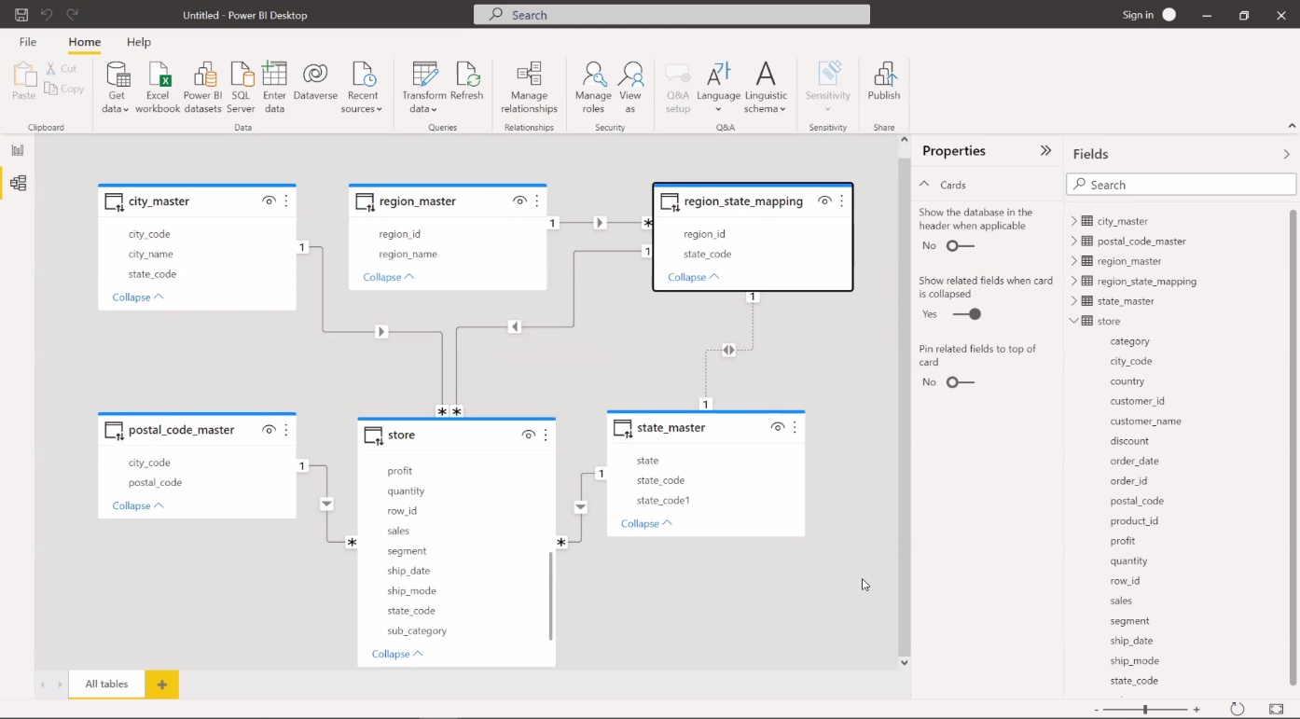

**State wise sales and profit analysis.**

The picture below represents the sales and profit analysis of states according to the region. It also depicts the total sales as well as the net profit as and when we select the region from the filter card.

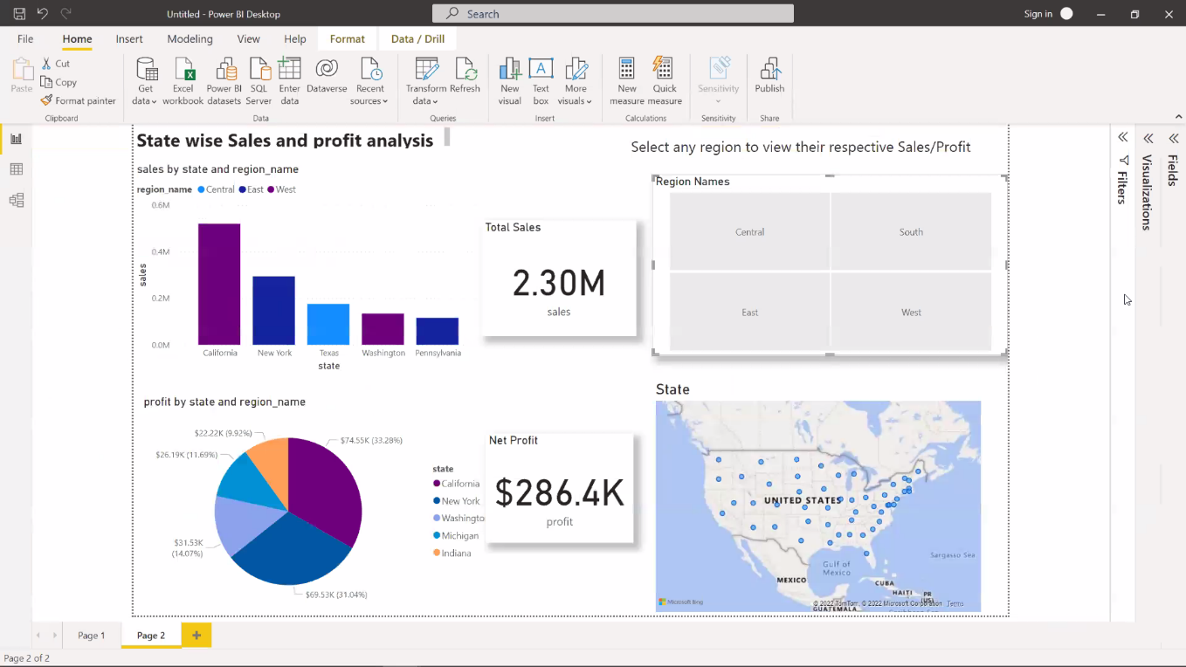Few more snapshots of the sales/profit analysis.

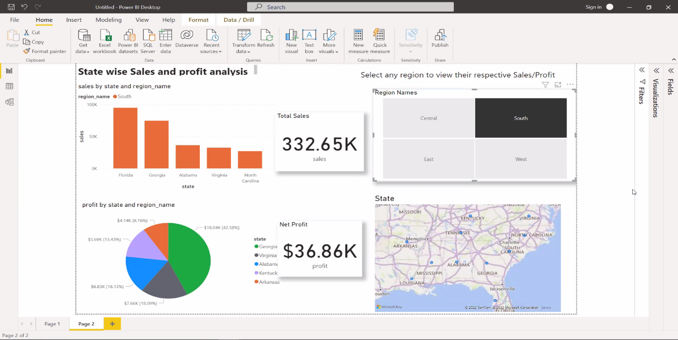

The below graph shows sales/profit analysis of east region.

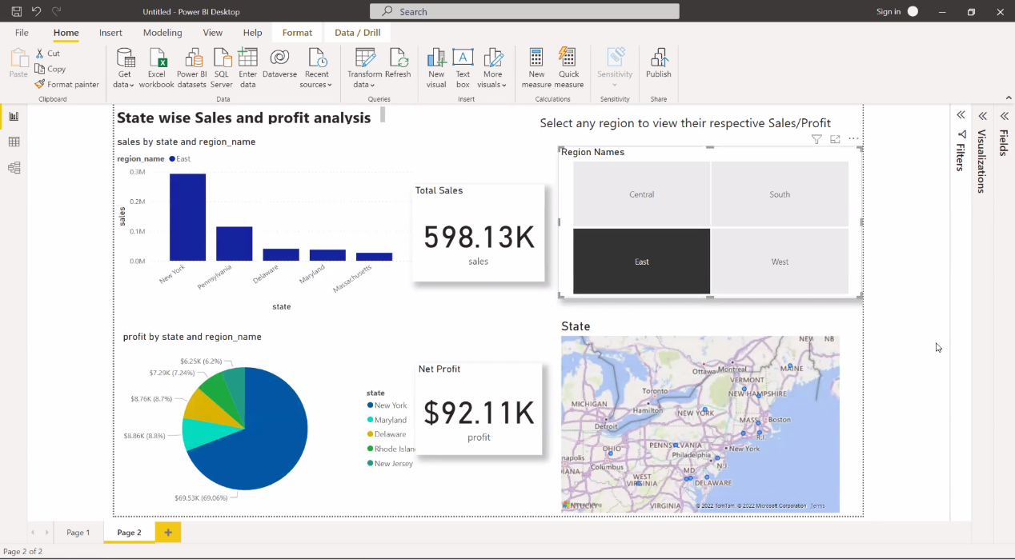 **Waterfall chart to represent the sales/profit trend.**

The dashboard below consists of waterfall charts that depicts the trend analysis for sales and profit of states based on the region which is controlled by the filter card that contains the region name and another filter that is the time period slider so when a region is selected and the slider is set it shows the trend analysis for that region.

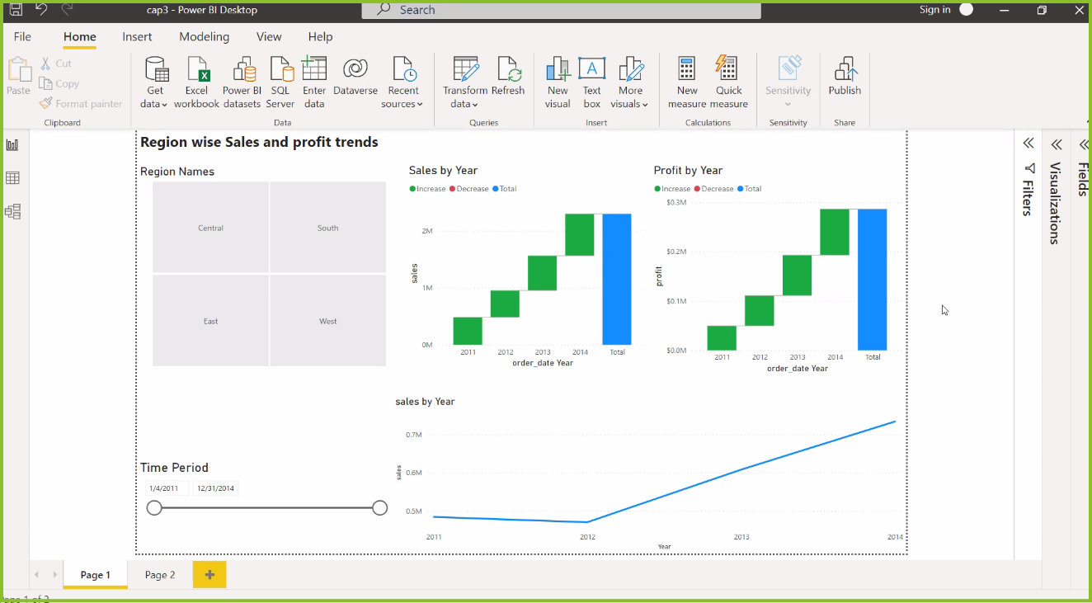

Few more snapshots of the sales/profit trend analysis.

This graph shows the sales/profit trend analysis of west region.

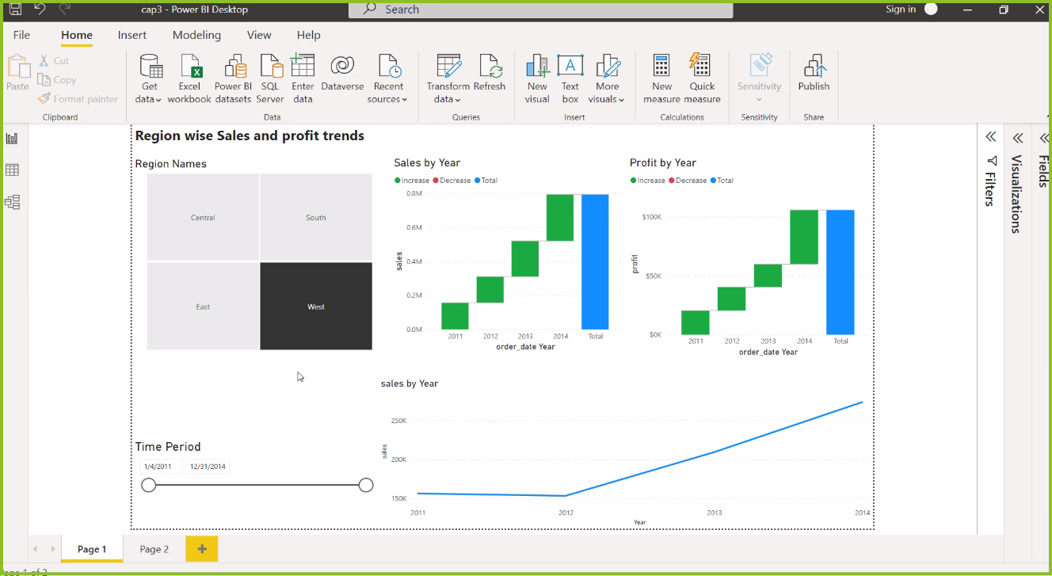

This graph shows the sales/profit trend analysis of south region.

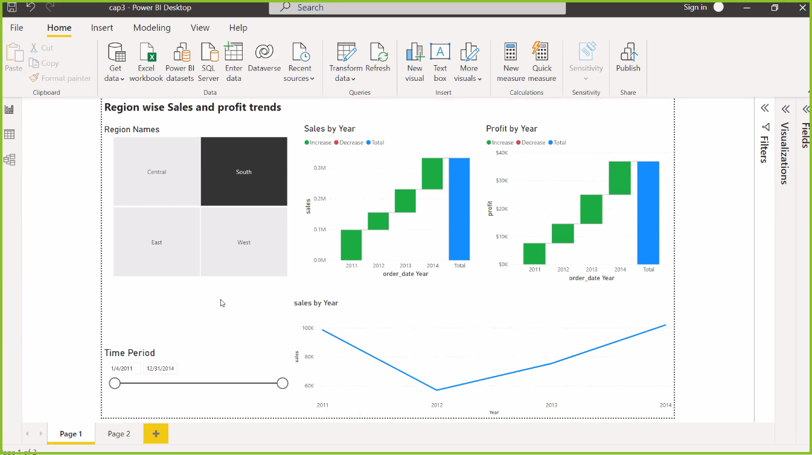

This graph shows the sales/profit trend analysis of east region.

